Kernel Rollback / Grub Configuration
1St Step Run this command
This command open the main GRUB configuration file.
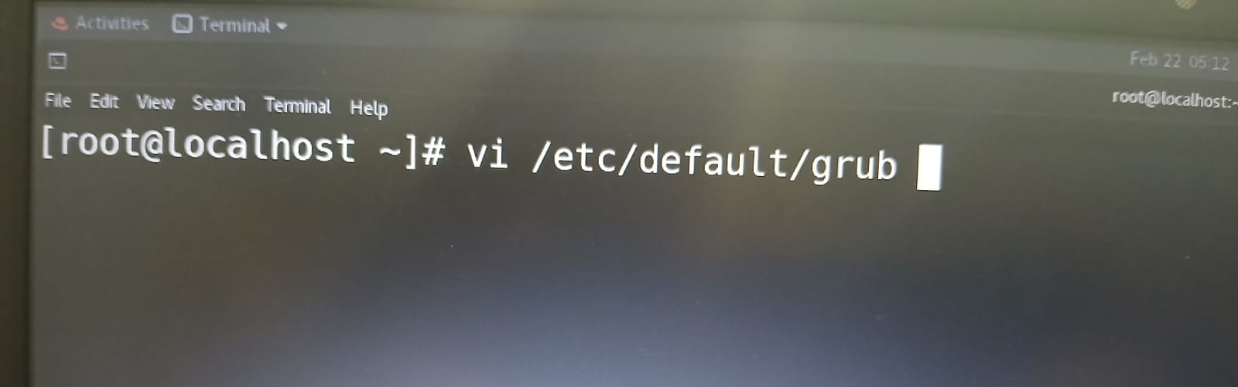
Output you will see
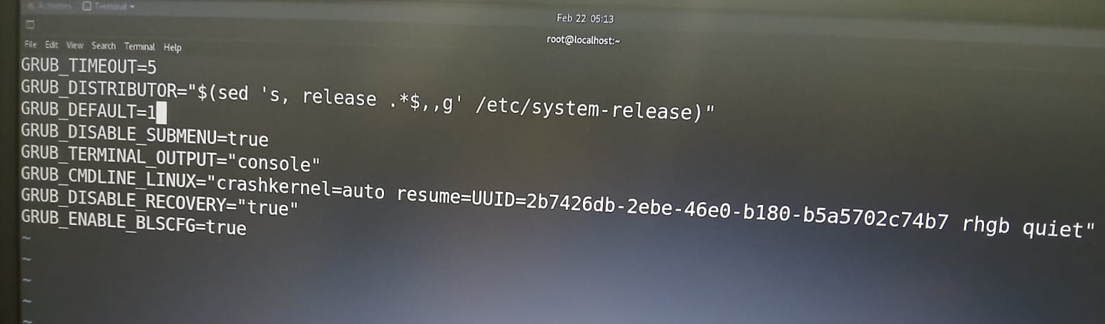
Set GRUB_DEFAULT=1
After that save The file
( This boot the 2nd kernel in the GRUB menu ( count start from 0 )
This steps selects the required kernel as the default boot option.

2ND Step Run this command
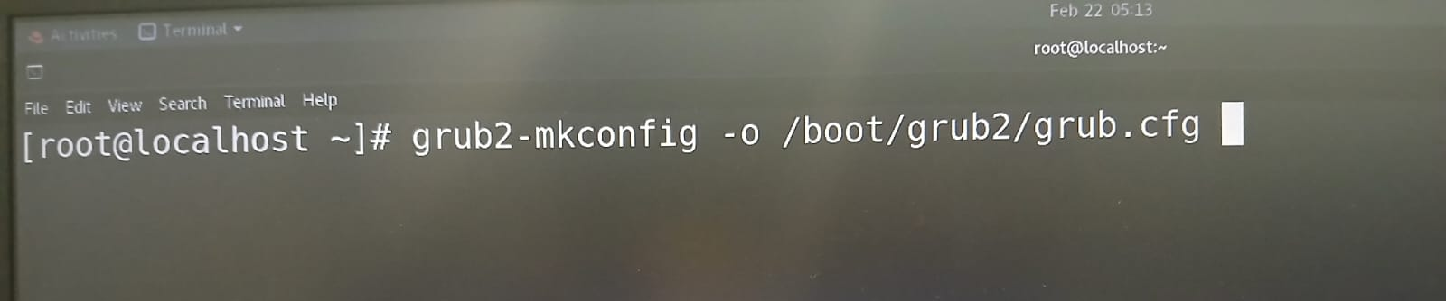
It applies the changes made in /etc/default/grub
After that reboot the system to apply the new default kernel.

